British Cardiovascular Society

New National Role: BCS Digital Education Fellow

Closing date: 21/10/2026

Role Profile

We are seeking to appoint a Cardiology Health Professional to an exciting national role entitled ‘BCS Digital Education Fellow’ to take over from our previous Digital Education Fellow. The fellowship programme will provide the successful post holder with funding and support to manage and drive forward plans for the ongoing development of an exciting and ambitious new initiative - the BCS Digital Knowledge Hub (DKH) and its integration into the main BCS website. The fundamental aim of the BCS DKH is to provide a comprehensive virtual learning environment for the UK cardiology workforce. The BCS DKH is a significant and pivotal aspect of the society’s future educational strategy and will provide the post holder an excellent opportunity to play a critical role in its delivery and development.

The post holder must be highly motivated, engaged, and digitally literate and will be responsible for the sustainable development of the DKH to support its breadth of scope and ultimately our ambition to establish it as an invaluable membership resource essential to all cardiology practitioners. This will be an exciting opportunity for NHS clinical staff with a background and firm grasp of cardiology, to shape and accelerate a digital education strategy. For cardiologists in training this would suit a Cardiology SpR between ST3-ST6. The post would suit someone interested in utilising the experience and skills gained from this role to pursue a master’s degree in leadership or education.

Funding
The Fellowship will fund up to £1000 pcm for an anticipated 1 working day per week by the fellow. The programme is flexible as to how this time is taken monthly (i.e., 4 days commitment per month can be done flexibly as per the fellow’s schedule) to achieve pre-specified outcome measures.

Term of office
The post is being offered as a 1-year consultancy contract in the first instance, with a review point at 6 months. A quarterly review will be conducted to assess progress towards outcomes.

Application process
- Please complete and submit your CV and covering letter, which should detail:
your experiences, enthusiasms, aspirations, and career plans that you feel make you suited to take on this role.
- Given that video content is a major element of the DKH we ask you to submit a 2-minute video as part of the application process. The content of the video can be a cardiology topic of your choice (clinical or non-clinical) within the remit of the BCS DKH as per Figure 1 which details the breadth and scope of the DKH. The video can be shot on equipment of your choice. Expensive equipment and software are not a prerequisite - a smartphone and free editing software is sufficient - what we are looking for is your ability to succinctly and clearly communicate and present a topic. If the video features individuals other than yourself then appropriate permissions would need to accompany the video.
- If your application is shortlisted, you will be invited to an interview which could be either online or face-to-face. You will then be notified of the outcome of your interview shortly afterwards.

Context

The BCS has a vision at the heart of its 5-year strategy to be the leading voice for UK cardiology and the go-to organisation for clinical standards in cardiology which should cover both clinical and non-clinical matters.

The COVID-19 pandemic forced the acceleration of digital working practices and is an opportunity for the BCS to re-imagine our duty to our society members. Globally we are seeing huge strides in the use of remote working, video conferencing/consultations and online education and it is clear this shift in culture is here to stay.

In line with our ambitions the BCS plans to increase its digital presence and will do so through the provision of a comprehensive virtual learning environment for our membership; the ‘Digital Knowledge Hub’ (DKH).

The concept of the DKH is far-reaching and the ethos underpinning the project is to provide high quality, easily digestible material which would impart actionable knowledge. It will be inclusive and collaborative in terms of contributors to fully represent our cardiology workforce.

The DKH successfully launched with a website holding specifically curated videos (https://digitalknowledgehub.co.uk/) in June 2022 and the plan is for the next Digital Education Fellow to:
- Oversee the integration of DKH content into the main BCS website
- Drive forward future video recording and editing (aiming for 3 videos per month),
- Work on marketing to continue making BCS e-learning content revenue neutral-to-positive for the BCS,
- Work on raising awareness and engagement by the BCS membership with the website.

Responsibilities

General
The BCS Digital Education Fellow will report to the DKH sub-committee of the Education Committee who will provide oversight and overall strategic support and development. They will collaborate closely with other key stakeholders including VP for Education and Research; Honorary Secretary, Chair of the Digital, Communications and Marketing Committee; the BCS Digital team; sub-committee members; trainees; BCS ex-officio and BCS members.

The BCS Digital Education Fellow will work with the Clinical Lead and staff managers to ensure key measures and deliverables are met, including:

- Drive forward future video recording and editing (aiming for 3 videos per month),
- Together with BCS staff, work on marketing to continue making the website revenue neutral-to-positive for the BCS,
- Work on raising awareness and engagement by the BCS membership with the website.

Specific duties
- Facilitate the DKH’s development and delivery in collaboration with the Clinical Lead and the Head of Digital Transformation

- Plan roadmap for the appointed term in terms of content output with at least 3 videos per month.

- Explore all avenues of the DKH Content model as shown in Figure 1 (see attachment) and develop areas not tackled in initial phases of release

- Attend planning and progress meetings with the Clinical Lead and staff leads as required.

- Chair meetings of the DKH sub-committee of the Education Committee ensuring that the meeting delivers on outputs in line with agreed Terms of Reference and project timelines

- Work with the Clinical Lead and Head of Digital Transformation to ensure agendas, papers and minutes are prepared in support of the sub-committee’s work on a timely basis and in accordance with BCS target timelines

- Ensure outputs and progress are appropriately tracked using agreed tools for governance and reporting purposes to the Clinical Lead, who in turn, is accountable to the BCS Digital Project Board for effective delivery of the hub in line with strategic goals and in harmony with other BCS educational initiatives and activities.

- Provide reports and / or presentations to the Education Committee, and to the Digital Project Board, Executive and BCS Board of Trustees in collaboration with the Clinical lead as required.

- Work with Head of Digital Transformation and other BCS staff as necessary to maintain and keep DKH website up to date

- Work with Head of Digital Transformation to maintain an inventory of content including longevity (retirement date)

- Develop keywords/tagging (metadata) to enhance search function of website

- Alongside the Head of Digital Transformation, develop website capabilities with appropriate external help to utilise AI to optimise user interface.

- Working with the Head of Digital Transformation, undertake iterative review of digital content, engagement statistics, feedback, and financial data (income, expenditure, and outturn) to inform proposals and recommendations for further content for development and plans

- Establish clear lines of engagement with other divisions within the BCS to ensure joined up approach and alignment with other key strategic goals of the organisation.

- Develop aspects of digital, marketing and communications in collaboration with the Clinical and staff leads including the BCS Marketing Manager to promote the DKH effectively and to support delivery of key deliverables

- Work closely with BJCA and promote and develop bilateral content sharing arrangements with other affiliate societies.

- Develop regional network of SpR’s and Consultants to ensure appropriate coverage of the UK in terms of geographical distribution of contributors

- To act as spokesperson for the DKH when required to do so.

Figure 1 DKH Breadth of Content

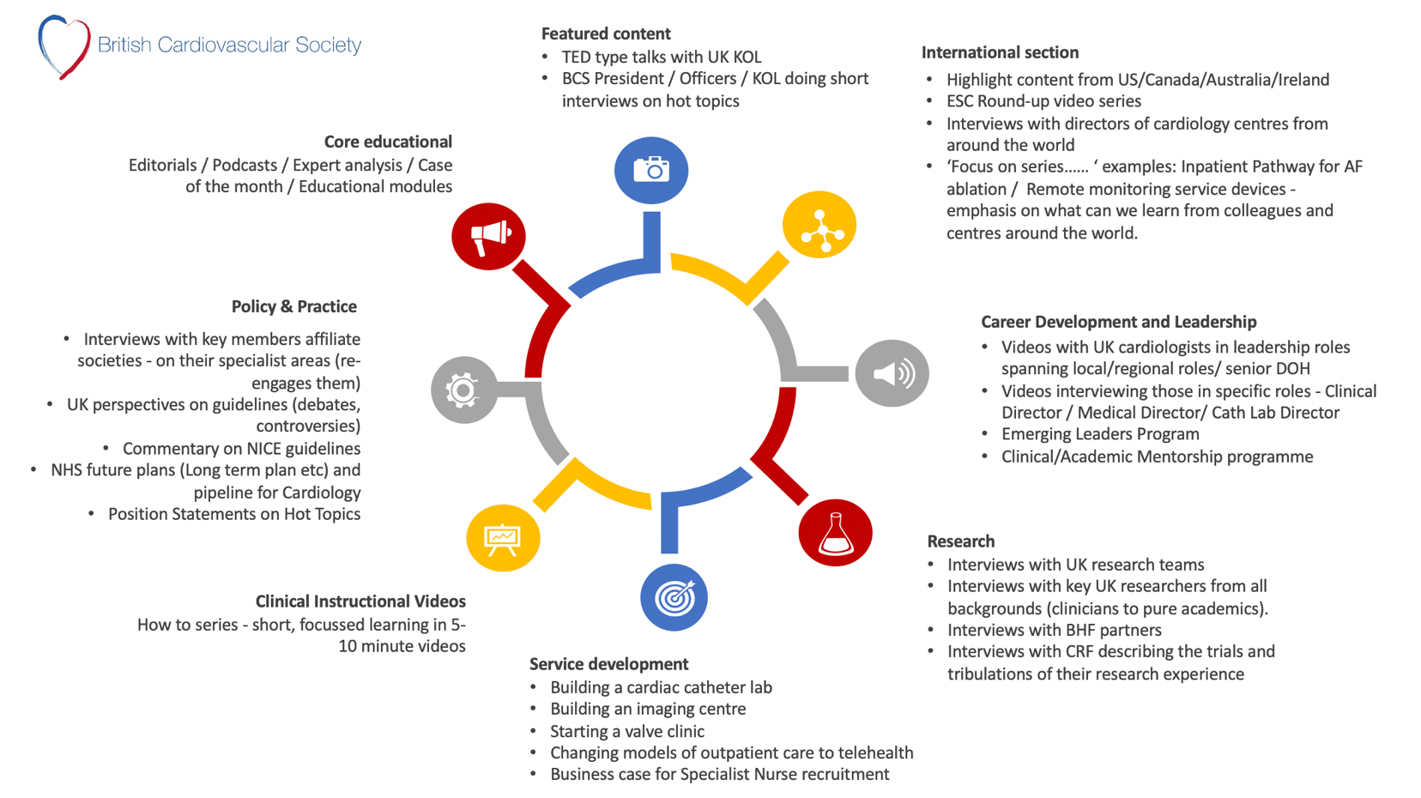

Person Specification

Attribute or Skill | Essential | Desirable
Specialist Expertise in Digital technologies | Thorough knowledge of the digital environment  Experience of development / administration / and management of digital content.  Familiarity with WordPress website management.  development  Experience  Pre-existing digital presence | Similar related experience to the role.  Website development/management
Appropriate skills | Demonstrable leadership qualities.  Ability to work well in a team and communicate effectively.  Evidence of commitment to the NHS.  Effective clear verbal and written communication skills.  Good knowledge of the Equality and Diversity principles contained in the Equality Act 2010 and how they apply to medical education.  To have completed a formal course in Equality and Diversity. | Evidence of the use of initiative.
Education Expertise | Previous experience in managing social media feeds / website development  A strong social media profile | Creation and development of digital professional or educational programs  Previous roles within NHS or other professional organisations’ developing and managing digital content and development

Clinical Expertise | To be in good standing with employer and GMC. | Achievement and additional contributions to specialty
Specialist Representation | To be a Member of the BCS (all membership categories)

Roles and responsibilities set out in this document will be reviewed every 2 years September 2026



Appendix 1: BCS Committee Governance Structure at Dec 2025
